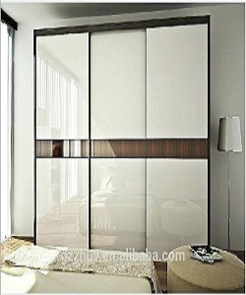

Modern and stylish Poliform wardrobe

$163.39

Availability: In stock

Description

Stylish and glamour Polifom wardrobe. Designed with a lavish modern style, Seattle, is a wardrobe with special light white sheet that enhance the exclusive quality of the wood. It is easy to open, assemble and all comes together in one box. Available in different size and colors.